7.1.4 Editors - 3D View - Header - Navigation Menu
All Modes - Navigation Menu 2
Orbit Down 2
Orbit Up 2
Orbit Right 2
Orbit Left 2
Orbit Opposite 2
Roll Left 2
Roll Right 2
Pan Down 2
Pan Up 2
Pan Right 3
Pan Left 3
Zoom Region 3
Zoom In 3
Zoom Out 3
Zoom Camera 1:1 3
Dolly View 3
Center View to Mouse 3
Fly Navigation 3
Walk Navigation 3
View Navigation 4
Playback Animation 4
Move 4
Last Operator Move 4
Move X , Y, Z 4
Orientation 4
Proportional Editing 4
Proportional Falloff 4
Proportional Size 4
Connected 4
Projected ( 2D) 5
Rotate 5
Last Operator Rotate 5
Angle 5
Axis 5
Orientation 5
Proportional Editing 5
Proportional Falloff 5
Proportional Size 5
Connected 5
Projected ( 2D) 5
Scale 6
Last Operator Scale 6
Scale X Y Z 6
Orientation 6
Proportional Editing 6
Proportional Falloff 6
Proportional Size 6
Connected 6
Projected ( 2D) 6

All Modes - Navigation Menu
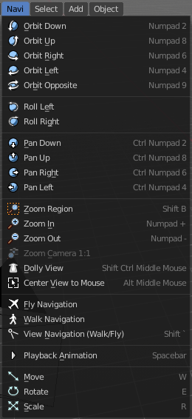
The Navigation menu provides you with all tools around viewport navigation. It is available in all modes.

Orbit Down
Orbits downwards.

Orbit Up
Orbits upwards.

Orbit Right
Orbits to the right.

Orbit Left
Orbits to the left.

Orbit Opposite
Rotates the view by 180 degree.

Roll Left
Rolls the viewport counter clockwise.

Roll Right
Rolls the viewport clockwise.

Pan Down
Pans the viewpoint downwards. The scene moves up.

Pan Up
Pans the viewpoint upwards. The scene moves down.

Pan Right
Pans the viewpoint to the right. The scene moves to the left.

Pan Left
Pans the viewpoint to the left. The scene moves to the right.

Zoom Region
Draws a rectangle and zooms then to fit the size of this rectangle.
Zooming in is done with drawing the rectangle with left mouse button. Zooming out is done with drawing the rectangle with middle mouse button.

Zoom In
Zooms into the viewport. Works also in camera view.

Zoom Out
Zooms out of the viewport. Works also in camera view.

Zoom Camera 1:1
Zooms the camera fitting to match the render output size by factor 1:1

Dolly View
Dolly View is a special zoom mode.
Be careful with this navigation method, you can easily trap yourself to not zoom able anymore!

Center View to Mouse
Centers the view to the current mouse position.

Fly Navigation
Switches to Fly navigation. In this view mode the camera acts like an air plane. Right click leaves the fly mode.

Walk Navigation
Switches to Walk Navigation. In this view mode the camera acts like a player in a first person shooter. Gravity will pull you down, The ground grid is the ground. And you can move around with wasd keys. Right click leaves the walk mode.

View Navigation
Switches to View Navigation Mode. In this view mode the view gets rotated moved and scaled from the Camera view point. Right Click leaves the view mode.

Playback Animation
Plays back an existing animation.

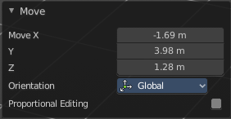
Move
Moves the selected object in the viewport by moving the mouse.

Last Operator Move

Move X , Y, Z
Adjust the position values for the three values

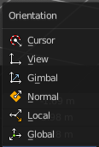
Orientation
Orientation is a drop-down box where you can choose the type of orientation for the transform action.

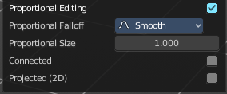
Proportional Editing
When you turn on proportional editing then further settings appears.
Proportional Editing is a drop-down box where you can choose to use proportional editing. When you choose one of the active methods then the neighbour geometry gets influenced by Shrink/Fatten too in a proportional way.

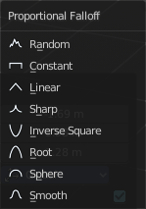
Proportional Falloff
Proportional Editing Falloff is a drop-down box where you can choose a method for the falloff for the proportional editing.

Proportional Size
Proportional size is a edit box wAdjust the strength of the Proportional falloff.

Connected
Just edit geometry that is directly connected with the current selection.

Projected ( 2D)
Edit geometry that is in 2d space aligned with the current selection. This one goes from the current view in depth direction.

Rotate
Rotates the selected object in the viewport by moving the mouse.

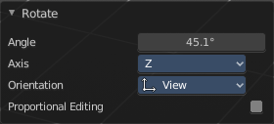
Last Operator Rotate

Angle
Adjust the rotation angle.

Axis
Around which axis to rotate. X, Y or Z.

Orientation
Orientation is a drop-down box where you can choose the type of orientation for the mirroring action.

Proportional Editing
When you turn on proportional editing then further settings appears.
Proportional Editing is a drop-down box where you can choose to use proportional editing. When you choose one of the active methods then the neighbour geometry gets influenced by Shrink/Fatten too in a proportional way.

Proportional Falloff
Proportional Editing Falloff is a drop-down box where you can choose a method for the falloff for the proportional editing.

Proportional Size
Proportional size is a edit box wAdjust the strength of the Proportional falloff.

Connected
Just edit geometry that is directly connected with the current selection.

Projected ( 2D)
Edit geometry that is in 2d space aligned with the current selection. This one goes from the current view in depth direction.

Scale
Scales the selected object in the viewport by moving the mouse.

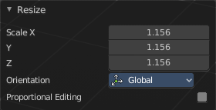
Last Operator Scale

Scale X Y Z
Adjust the position values for the three values

Orientation
Orientation is a drop-down box where you can choose the type of orientation for the mirroring action.

Proportional Editing
When you turn on proportional editing then further settings appears.
Proportional Editing is a drop-down box where you can choose to use proportional editing. When you choose one of the active methods then the neighbour geometry gets influenced by Shrink/Fatten too in a proportional way.

Proportional Falloff
Proportional Editing Falloff is a drop-down box where you can choose a method for the falloff for the proportional editing.

Proportional Size
Proportional size is a edit box wAdjust the strength of the Proportional falloff.

Connected
Just edit geometry that is directly connected with the current selection.

Projected ( 2D)
Edit geometry that is in 2d space aligned with the current selection. This one goes from the current view in depth direction.

